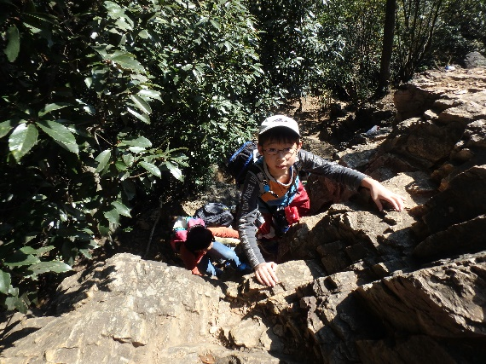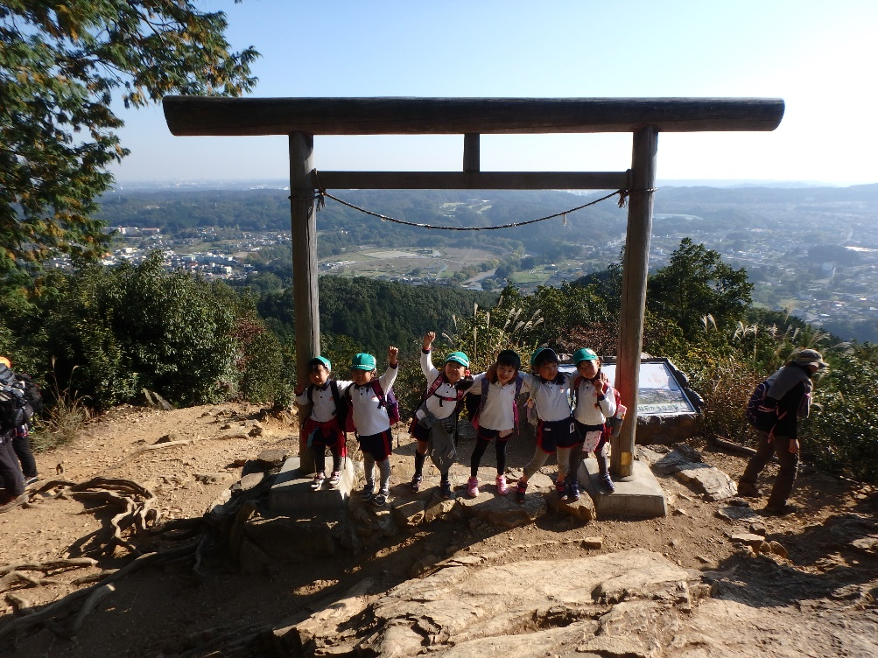[](https://3.bp.blogspot.com/-0WUmmPLdfNs/W3abTu71iMI/AAAAAAABOAY/nf9KeWtOk7kv77jKFfp2pwP0hi8hoo7YwCLcBGAs/s800/hebi_aodaisyou.png)[](https://2.bp.blogspot.com/-R-XVqRsWq_o/WXcRC6-fNTI/AAAAAAABFps/t4i2Su5UXwINaYzX8khQrApA3ZjOrv2uACLcBGAs/s800/animal_mogura_kouji2.png)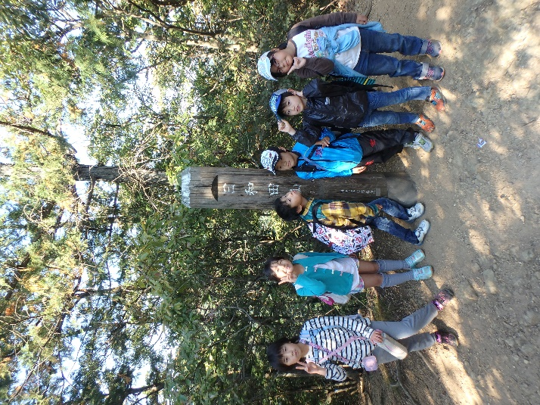[](https://3.bp.blogspot.com/-VLeooPHq-SA/UgSMFKdLR3I/AAAAAAAAW7c/PRulas6hgG4/s800/food_obentou.png)[](https://1.bp.blogspot.com/-NX2hDnkX3cI/Wat2oqWh8mI/AAAAAAABGZ0/iuwwwHSLzesGZA6KI6PN_wsv4BV72oACwCLcBGAs/s800/jiko_kuma_sougu.png)[](https://1.bp.blogspot.com/-a0CNxQY1i3M/UZYk6yd9OMI/AAAAAAAATH8/tl6ZGv6tMOg/s800/ensoku_obentou.png)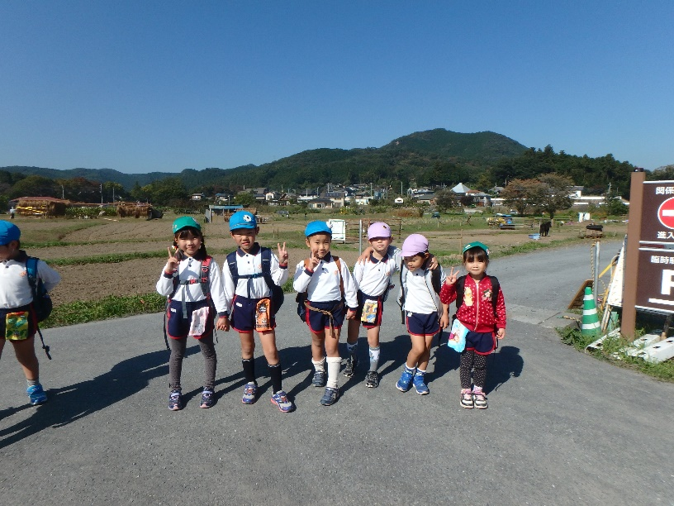[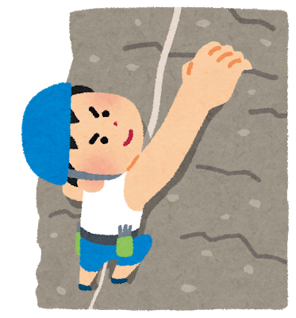](https://2.bp.blogspot.com/-6rG-nhEkwEo/U8Xkn5dIbrI/AAAAAAAAi0s/rxwSOf168ag/s800/sports_rock_climbing.png)

**日程：１１月１２日（土）**

**延期日：１１月１９日（土）**

**秋の山登り**

日　程：20２２年１１月６日（日）※雨天等延期

場　所：埼玉県　日高市　巾着田～日和田山

対　象：年長児～小学生のみ。

定　員：５０名（予定）

参加費：￥２，８００（会員）　￥３，８００（一般）